GUIDE TO THE ORDER SYSTEM

LOG IN:

USER: DAVID

PASSWORD: DAVID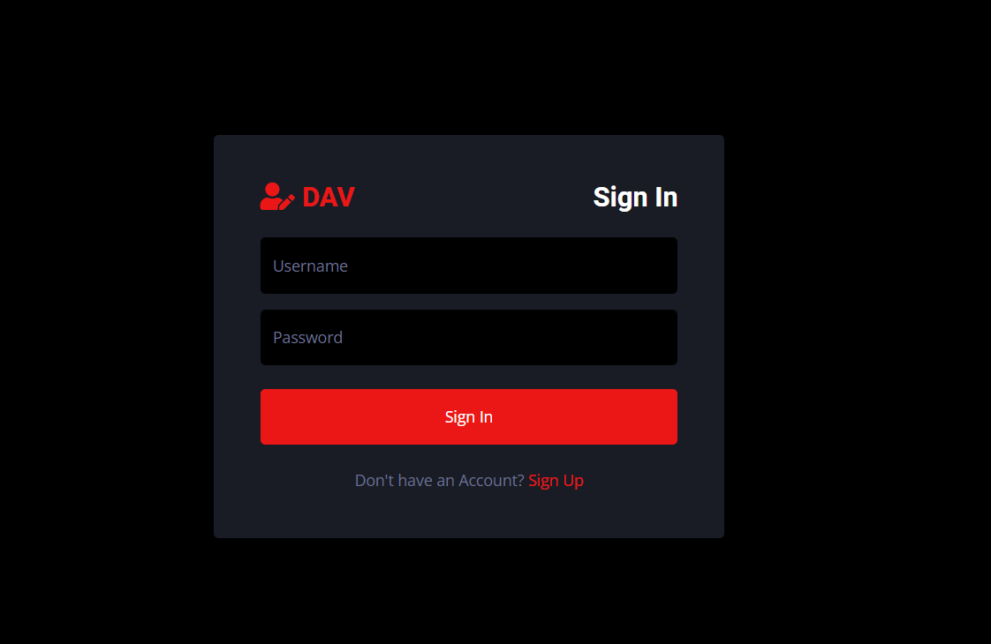

DASHBOARD:

PROFILE AND LOG OUT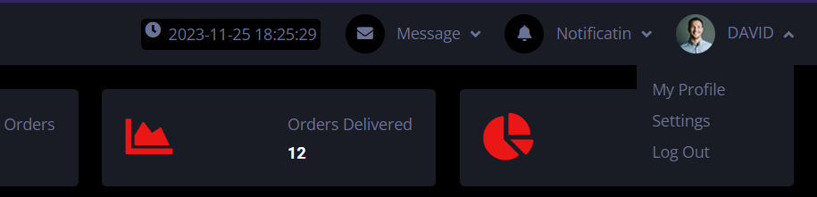

HERE WE FIND NUMBER OF ORDERS, DAILY, WEEKLY, DELIVERIES, AND TOTAL



BAR AS A SUMMARY OF GENERAL DATA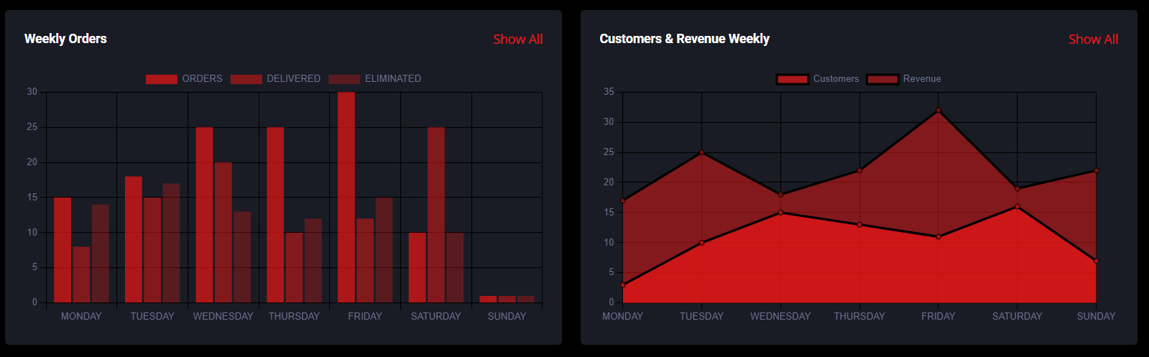

LATEST ORDER DETAILS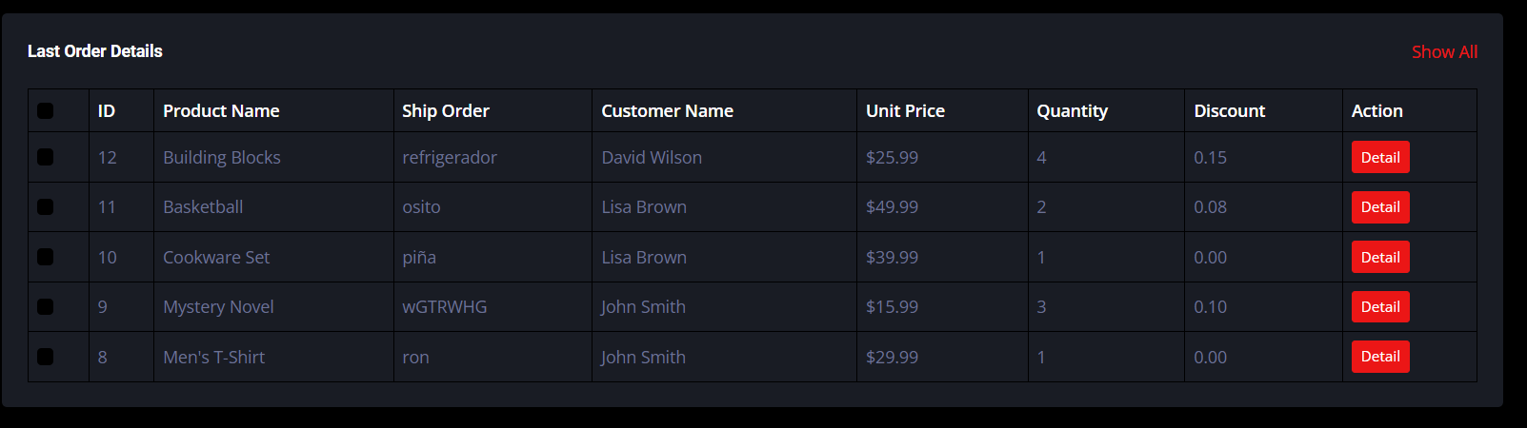

CALENDAR TAKES DATE SYSTEM

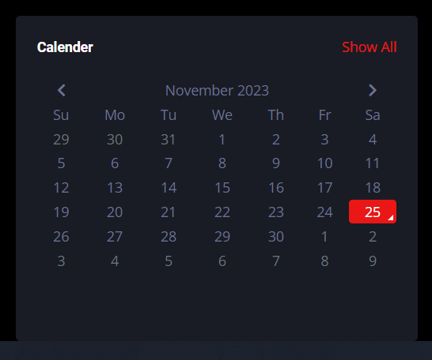

WE ENTER THE ORDER, ENTER ALL THE DATA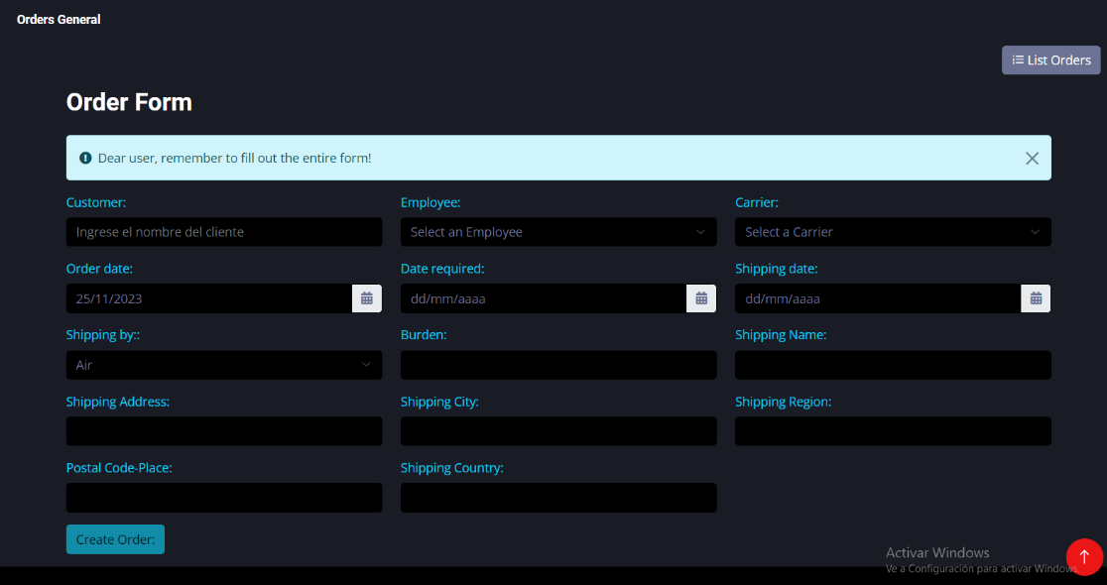

ORDER LIST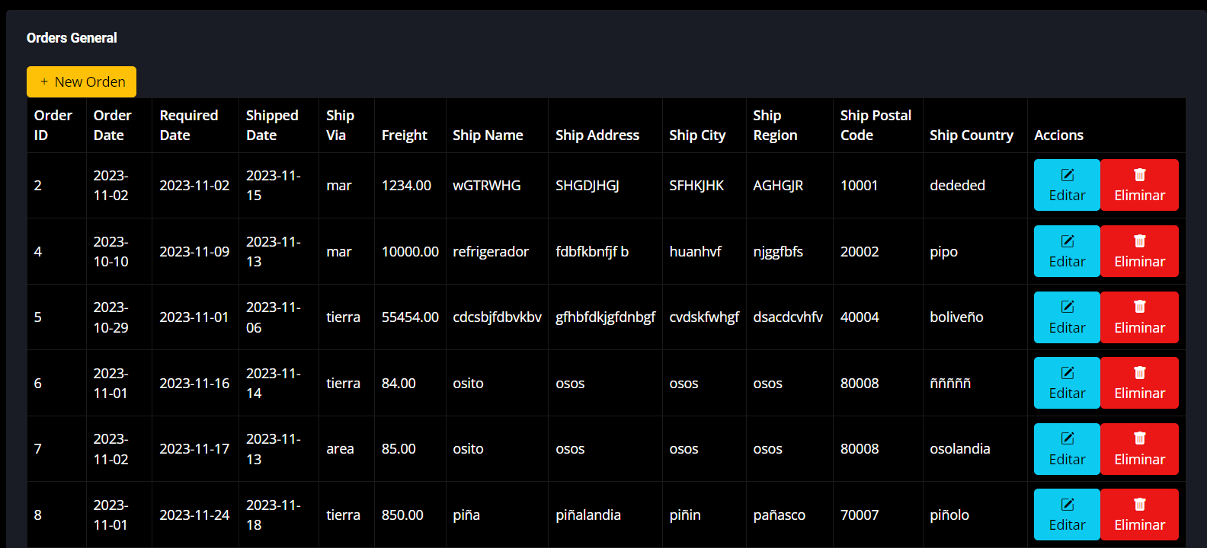

EDIT AND DELETE OPTIONS

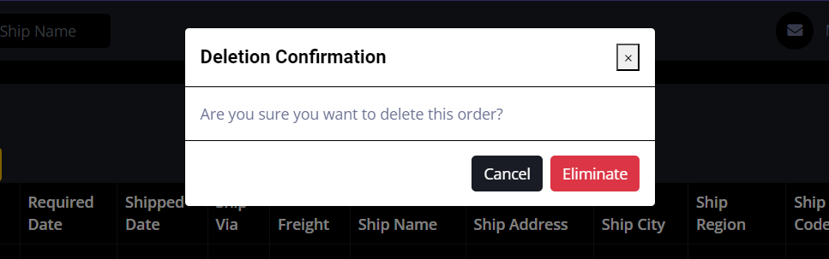

AND EDIT COPIES ALL THE DATA

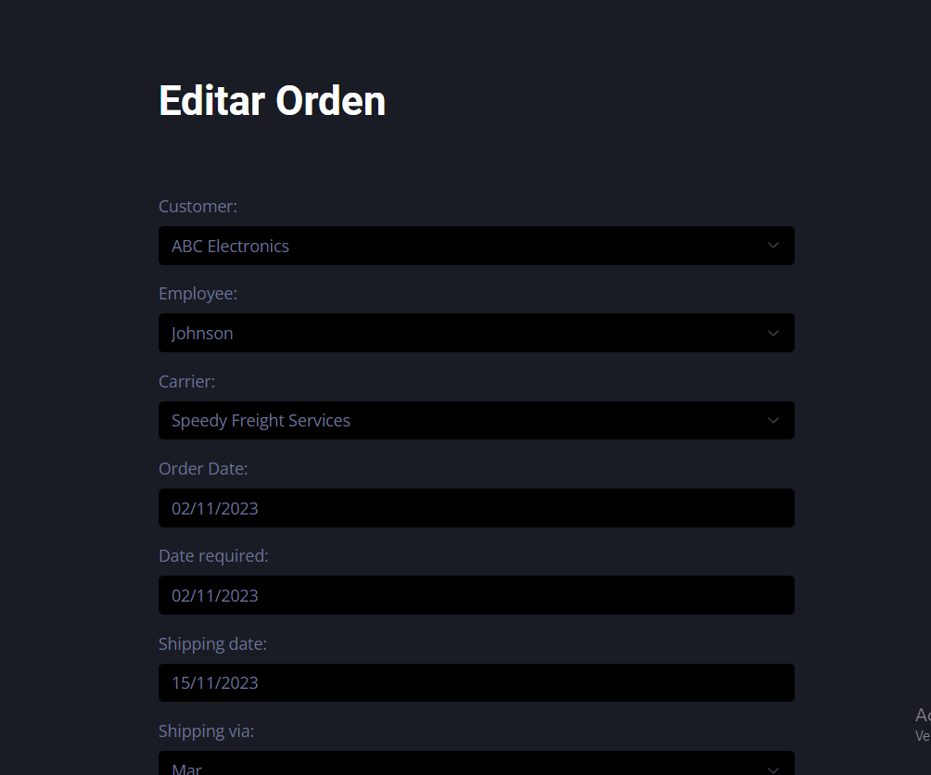

AND FINALLY MY PROFILE WHERE YOU WILL FIND MORE DATA AND CLOSE SESSION

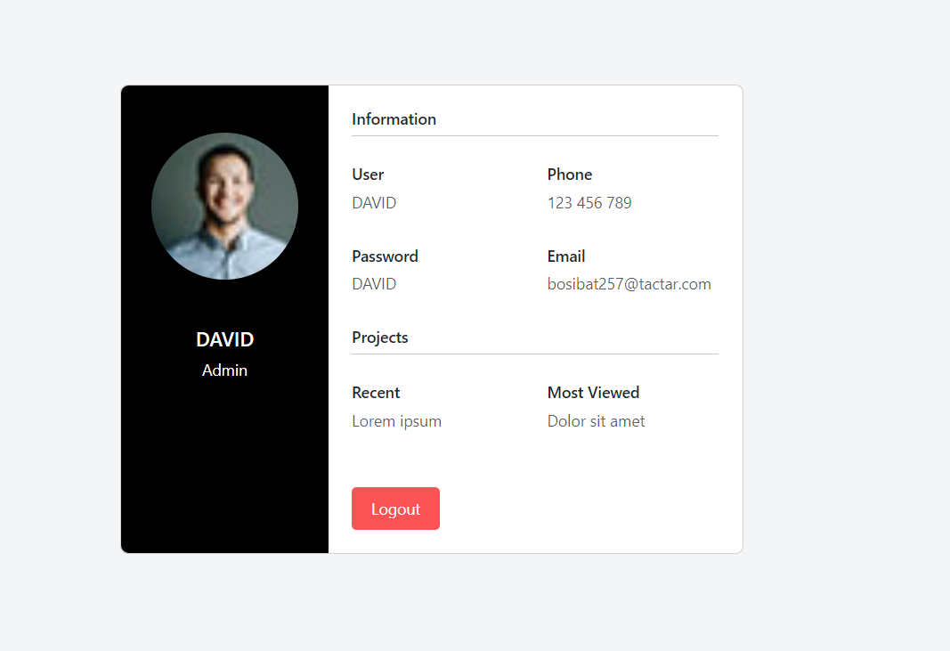

OPTIONS ON THE LEFT PART

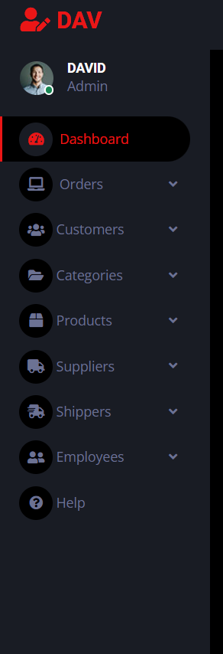

AND THIS IS IN THE CATEGORIES PART 